UNIT–1 MINI PROJECT
ENTERPRISE STUDENT RECORD AND
ACADEMIC MANAGEMENT PLATFORM
Submitted as part of Unit–1 Mini Project
Student Name: Shaikh Mahek Tanveer
PRN.: 2126UMLF2518
Class / Semester: 3rd sem
Department: AIML
Institute: Sanjivani University
Academic Year: 2026–27

ACKNOWLEDGEMENT

I sincerely thank my faculty for providing the guidance and reference material required to complete this Unit–1 mini project. I also thank my department and institute for providing the learning environment and resources needed to understand Design Thinking, requirements engineering, product planning, and software product development.
This mini project helped me understand how a software product is planned from the user's problem and business requirements before actual coding begins.

INDEX
- 1. Introduction to Software Product Development
- 2. Business Understanding – Academic Management
- 3. Design Thinking
- 4. Applying the Five Stages of Design Thinking
- 5. IBM Design Thinking
- 6. IBM Loop Engine
- 7. Stakeholder Analysis
- 8. User Persona Development
- 9. Stakeholder Matrix
- 10. Functional Requirements Specification (FRS)
- 11. Non-Functional Requirements Specification (NFRS)
- 12. Product Vision
- 13. Minimum Viable Product (MVP)
- 14. Product Roadmap
- 15. Initial System Architecture
- 16. Project Charter
- 17. Project Repository Initialization
- 18. Project Folder Structure
- 19. Product Discovery Documentation
- 20. Business Problem and Solution Summary
- 21. Tables, Flowcharts and Diagrams
- 22. Conclusion

1. Introduction to Software Product Development
Software product development is not only the process of writing code. It includes understanding the problem, identifying users, gathering requirements, designing the solution, preparing the architecture, testing the product, and continuously improving it.

Programming / Coding vs Software Product Engineering
Dimension | Programming / Coding | Software Product Engineering
Primary Goal | Write executable code | Build a useful and maintainable software product
Scope | Individual functions or programs | Complete product lifecycle
Focus | How to implement | What problem to solve
Success | Code works correctly | Users can effectively use the product
Approach | Technology-focused | User and business-focused

Root Causes of Software Project Failures
- Misunderstanding user and business requirements.
- Developing unnecessary features.
- Poor communication between stakeholders and technical teams.
- Lack of early user feedback.
- Insufficient planning and documentation.
- Late testing and delayed problem identification.
- Not considering security and privacy of academic records.

2. Business Understanding – Academic Management
Before developing the platform, the academic management process must be understood. The proposed system focuses on student registration, course management, attendance, examinations, results, and academic reports.

2.1 Core Academic Operations
- Student Registration – maintaining student admission and profile details.
- Course Management – maintaining courses, subjects, and faculty allocation.
- Attendance Management – recording attendance and calculating attendance percentage.
- Examination Management – maintaining examination schedules and information.
- Result Management – entering marks, grades, and semester results.
- Report Generation – preparing student, attendance, and result reports.

2.2 Manual Process Challenges vs Automated Solution

Manual Operational Problem | Automated Platform Solution | Expected Benefit
Paper/manual student records | Centralized digital database | Easy record access
Manual attendance calculation | Automatic attendance calculation | Saves time
Searching records manually | Search and filter facility | Faster access
Manual result preparation | Automated result management | Reduces calculation errors
Manual report preparation | Automatic report generation | Saves administrative effort
Records stored separately | Centralized platform | Better organization

3. Design Thinking
Design Thinking is a human-centered, iterative approach used to understand users and develop solutions according to their real needs.
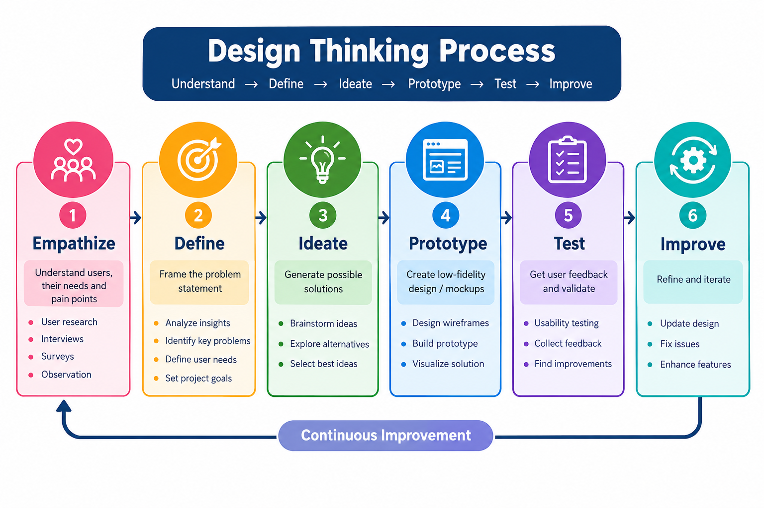

The process is repeated using feedback so that the solution can be improved before and during development.

4. Applying the Five Stages of Design Thinking

4.1 Empathize
The main user groups are students, faculty members, academic administrators, examination staff, and IT support personnel.
Important user problems include:
- Students may find it difficult to access attendance, marks, results, and academic records.
- Faculty may spend time entering attendance and marks manually.
- Administrators may face difficulty maintaining large volumes of student information.
- Examination staff may need organized access to examination and result data.

4.2 Define
Core Problem Statement: Students, faculty, and academic administrators face difficulties in managing and accessing student records, attendance, examination information, and academic results because information may be maintained manually or across separate records. A centralized platform is required to provide organized, secure, and easily accessible academic information.

4.3 Ideate
- Centralized student database.
- Student and faculty dashboards.
- Online attendance management.
- Automatic attendance percentage calculation.
- Examination and marks management.
- Result generation.
- Academic report generation.
- Search and filter facility.
- Role-based access control.
- Academic notifications.

4.4 Prototype
A low-fidelity prototype can contain:
- Login Page
- Admin Dashboard
- Student Dashboard
- Faculty Dashboard
- Student Registration
- Attendance Page
- Examination/Marks Page
- Result Page
- Report Generation Page

4.5 Test
The prototype can be tested with students, faculty, and administrators. Feedback should be collected about navigation, clarity, ease of use, and task completion.

5. IBM Design Thinking
IBM Design Thinking can be applied using three principles:

5.1 Focus on User Outcomes
The goal should focus on the user's outcome rather than only the technical feature.
Example: Instead of only "build an attendance module", the outcome is "enable students and faculty to view and manage attendance quickly and accurately."

5.2 Restless Reinvention
The platform should be continuously improved using user feedback, system performance information, and changing academic requirements.

5.3 Diverse Empowered Teams
- Product/Project Manager
- UI/UX Designer
- Software Developer
- Database Developer
- QA Tester
- IT/DevOps Support

6. IBM Loop Engine
The continuous IBM Loop can be represented as Observe → Reflect → Make.
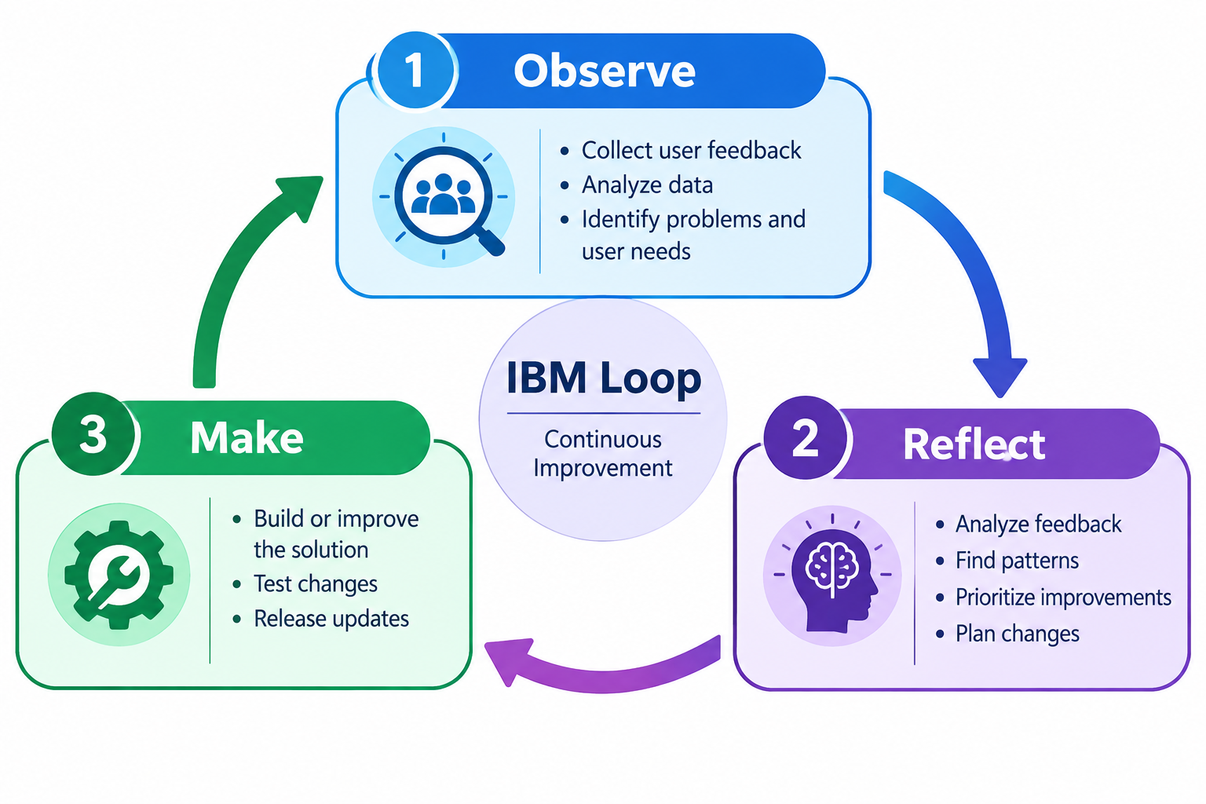

Observe: collect user feedback and usage information.
Reflect: analyze problems and decide what should be improved.
Make: develop or modify the feature and release the improvement.

7. Stakeholder Analysis
Stakeholder | Role | Responsibility / Need
Students | End Users | View profile, attendance, marks, results and reports
Faculty | Academic Users | Manage attendance, marks and student academic information
Academic Administrators | Management | Manage student records and generate reports
Examination Staff | Academic Operations | Manage examinations and results
IT Support | Technical | Maintain system, database and infrastructure
College Management | Business Stakeholder | Monitor academic information and outcomes

8. User Persona Development

8.1 Persona – Student
Attribute | Details
Name | Ayesha
Role | Student
Goal | Easily access academic information
Needs | Attendance, marks, examination schedule, results and reports
Pain Points | Manual access and waiting for academic records
Required Features | Student dashboard, attendance, results and notifications

8.2 Persona – Faculty
Attribute | Details
Name | Mr. Rahul
Role | Faculty Member
Goal | Manage academic activities efficiently
Needs | Attendance, marks, student information and reports
Pain Points | Manual entry and time-consuming calculations
Required Features | Faculty dashboard, attendance, marks and reports

8.3 Persona – Administrator
Attribute | Details
Name | Mrs. Priya
Role | Academic Administrator
Goal | Manage academic records accurately
Needs | Student, course, faculty and report management
Pain Points | Large data volume and manual report preparation
Required Features | Admin dashboard, student management and reporting

9. Stakeholder Matrix
Stakeholder Group | Examples | Main Responsibility
Business Stakeholders | College Management, Academic Admin | Define goals and validate requirements
User Stakeholders | Students, Faculty | Use the system and provide feedback
Engineering Stakeholders | Developers, UI/UX, QA | Design, develop and test the system
Operations Stakeholders | IT Support, Database Admin | Maintain infrastructure and database

10. Functional Requirements Specification (FRS)
ID | Requirement | Description
FR-01 | User Authentication | Secure login for Admin, Faculty and Student
FR-02 | Student Record Management | Add, update, view and manage student records
FR-03 | Course Management | Manage courses, subjects and faculty allocation
FR-04 | Attendance Management | Record, update and calculate attendance
FR-05 | Examination Management | Manage examination schedules and information
FR-06 | Result Management | Enter marks, update marks and generate results
FR-07 | Report Generation | Generate student, attendance and result reports
FR-08 | Search | Search student records using permitted fields

11. Non-Functional Requirements Specification (NFRS)
ID | Requirement | Description
NFR-01 | Security | Protect student information and restrict unauthorized access
NFR-02 | Performance | Provide timely responses for normal user operations
NFR-03 | Usability | Provide a simple and user-friendly interface
NFR-04 | Reliability | Maintain accurate records and reduce data-loss risk
NFR-05 | Scalability | Support growth in users and academic records
NFR-06 | Maintainability | Use a modular structure that is easy to update

12. Product Vision
Product Vision Statement: "To provide a centralized, secure, and user-friendly Student Record and Academic Management Platform that simplifies academic record management, improves accessibility of student information, reduces manual work, and supports students, faculty, and administrators."

13. Minimum Viable Product (MVP)
The MVP contains the essential features required for the first working version.
Feature | MVP / Future
User Login | MVP
Role-based Access | MVP
Student Registration | MVP
Student Profile | MVP
Course/Subject Management | MVP
Attendance Management | MVP
Marks Management | MVP
Result Generation | MVP
Basic Reports | MVP
Mobile Application | Future
AI-based Performance Prediction | Future
Parent Portal | Future
Advanced Analytics | Future

14. Product Roadmap
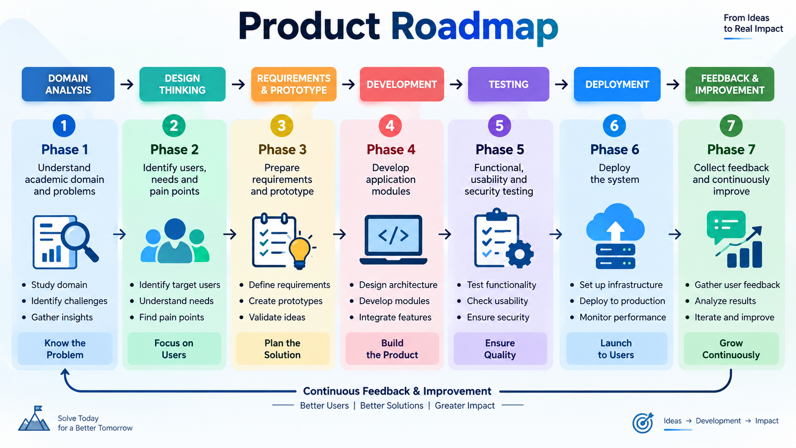
Phase | Activities
Phase 1 | Understand academic domain and problems
Phase 2 | Identify users, needs and pain points
Phase 3 | Prepare requirements and prototype
Phase 4 | Develop application modules
Phase 5 | Functional, usability and security testing
Phase 6 | Deploy the system
Phase 7 | Collect feedback and continuously improve

15. Initial System Architecture
Academic Modules: Student Management | Course Management | Attendance | Examination | Marks | Results | Reports
The architecture separates users, interface, application logic, academic modules, and stored data.
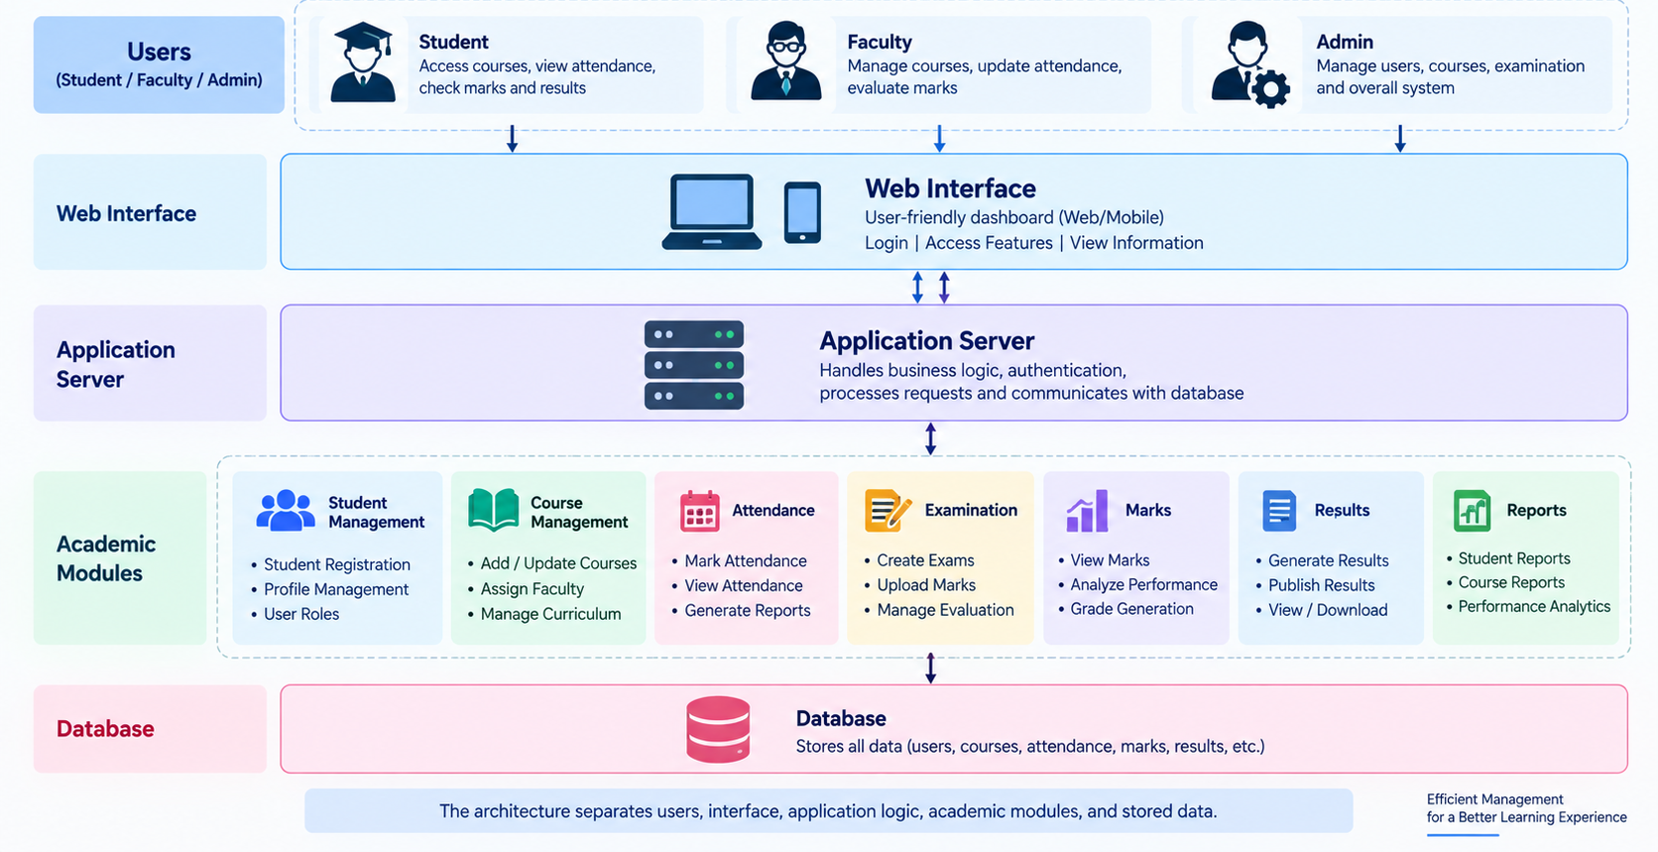

16. Project Charter
Item | Details
Project Name | Enterprise Student Record and Academic Management Platform
Objective | Develop a centralized platform for managing student records and academic information
Problem | Academic information may be maintained manually or across separate records
Target Users | Students, Faculty, Academic Administrators, Examination Staff
Expected Outcome | Organized, secure and accessible academic information with reduced manual work
Major Deliverables | BRD, Personas, FRS/NFRS, Design Thinking, MVP, Roadmap, Architecture and Product Discovery

17. Project Repository Initialization
The project repository should be initialized to store application source code, documentation, database files, tests and project configuration.

18. Project Folder Structure
student-academic-management/
│
├── .github/
│ └── workflows/
├── frontend/
│ ├── components/
│ ├── pages/
│ ├── assets/
│ └── services/
├── backend/
│ ├── controllers/
│ ├── models/
│ ├── routes/
│ ├── services/
│ └── tests/
├── database/
│ ├── schemas/
│ └── migrations/
├── docs/
│ ├── BRD/
│ ├── FRS/
│ ├── NFRS/
│ ├── Design-Thinking/
│ └── Architecture/
├── prototype/
├── README.md
└── .gitignore

19. Product Discovery Documentation
Discovery Area | Finding
Problem Discovery | Difficulty in managing and accessing student academic records
User Discovery | Students, faculty and administrators are the primary users
Need Discovery | Users need easy, accurate, secure and centralized information
Solution Discovery | A centralized web-based academic management platform
Feature Discovery | Login, student management, courses, attendance, exams, marks, results and reports
Success Criteria | Records are managed digitally and users can access required academic information efficiently

20. Business Problem and Solution Summary
Problem | Proposed Solution | Benefit
Manual student record management | Centralized digital records | Easy access and organization
Manual attendance | Digital attendance module | Faster and easier management
Manual marks and results | Result management module | Consistent calculations
Difficult report preparation | Automatic report generation | Saves time
Separate academic information | Centralized platform | Improved accessibility

21. Tables, Flowcharts and Diagrams

21.1 Student Registration Flowchart
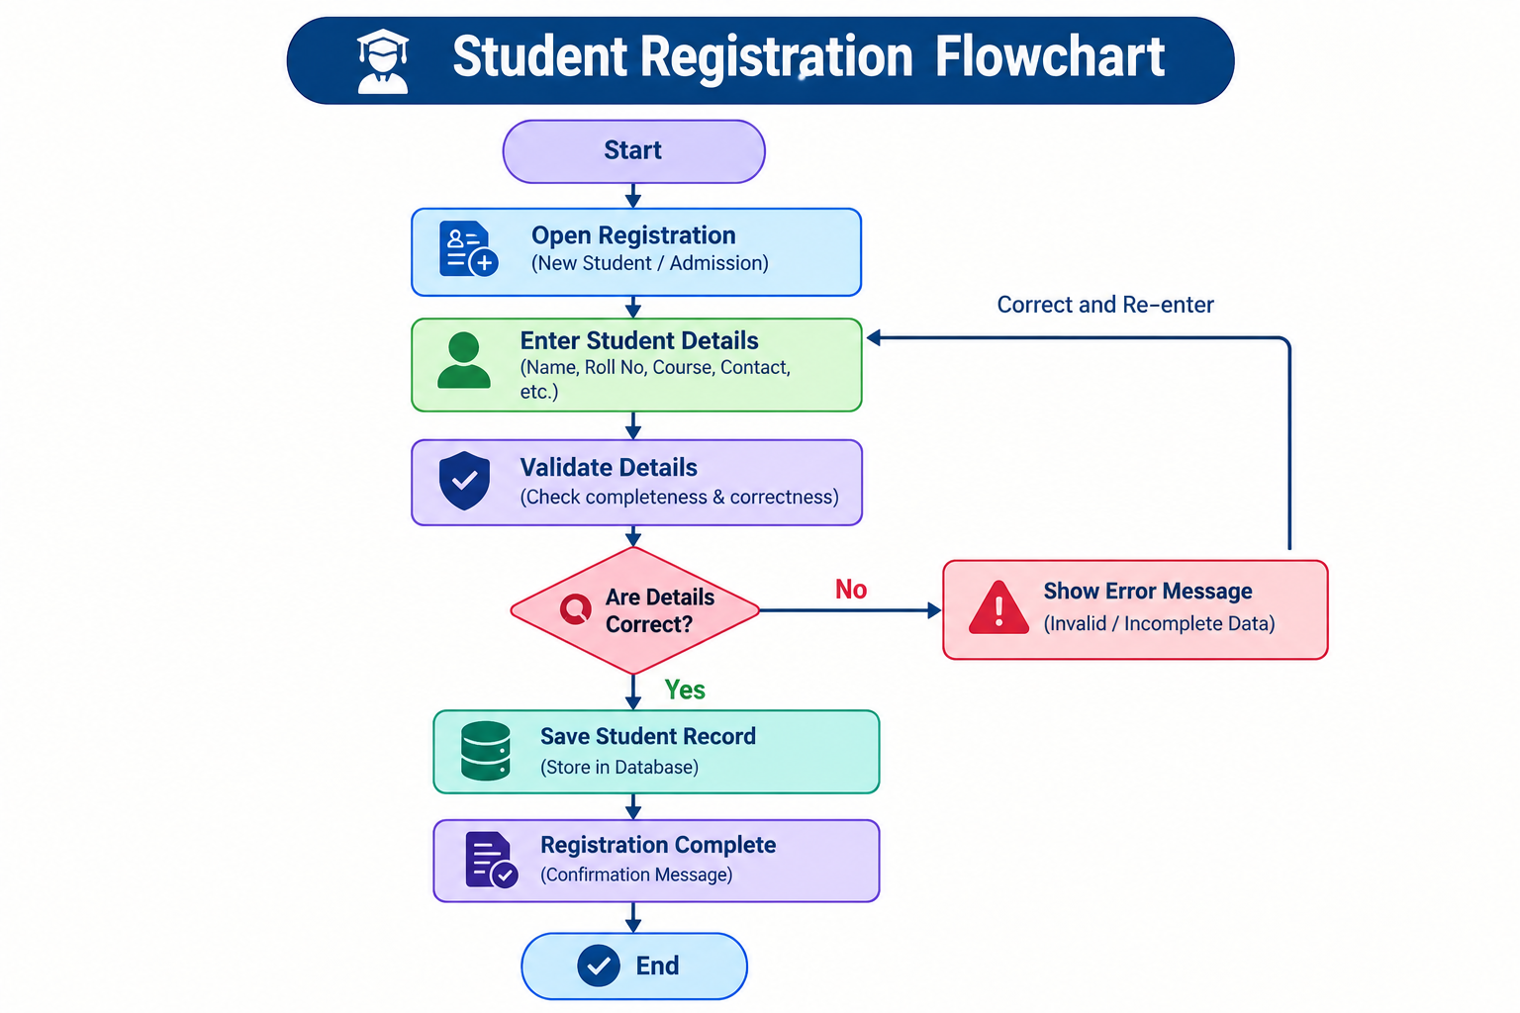

If the details are invalid, the user is asked to correct the information before the record is saved.

21.2 Academic Management Flowchart
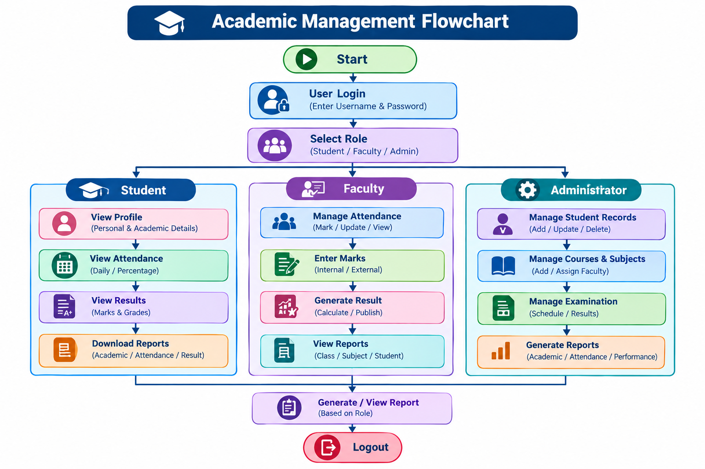

21.3 System Architecture Diagram
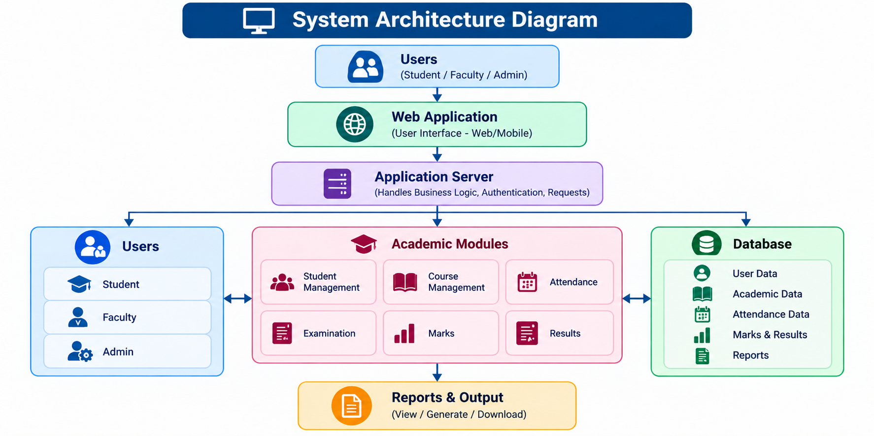

22. Conclusion
The Enterprise Student Record and Academic Management Platform is planned as a centralized solution for managing student records and academic information. Using Design Thinking, the project first identifies the needs of students, faculty, and administrators before defining requirements and the product vision.
The proposed MVP focuses on essential functions such as login, student management, attendance, marks, results, and basic reports. The roadmap, architecture, stakeholder analysis, personas, functional requirements, non-functional requirements, and repository structure provide a foundation for future development.
The main learning from this mini project is that successful software development begins with understanding users and the problem before implementation.

